Inputs:

X0: Algae

X1: Balanus

X2: Chthamalus_dalli

X3: Mytilus_trossulus

X4: Nucella_canaliculata

X5: Nucella Ostrina

X6: Semibalanus

X7: Temperature

X8: Day

Output:

Balanus Growth Rate

**1**

est_gp = SymbolicRegressor(population_size=1000,

generations=1000, stopping_criteria=140,

p_crossover=0.8, p_subtree_mutation=0.05, function_set=function_set,

p_hoist_mutation=0.01,

p_point_mutation=0.1,

max_samples=0.90, verbose=1,

parsimony_coefficient=.001, random_state=0)

Function set includes sqrt

div(div(div(mul(X0, X0), sin(neg(neg(sqrt(X8))))), neg(sin(sqrt(sqrt(sqrt(div(X7, neg(X3)))))))), div(cos(sin(X7)), sub(neg(div(sin(div(div(div(sqrt(add(neg(sin(sqrt(X6))), neg(div(sin(div(div(div(sqrt(add(neg(sin(sqrt(X6))), sub(sqrt(X1), sub(inv(sin(X6)), add(mul(cos(sqrt(0.332)), X6), div(sqrt(X6), sub(inv(X1), X2))))))), cos(cos(X5))), neg(div(div(sub(X4, X7), sub(X0, X2)), div(sqrt(mul(sqrt(sin(sin(neg(sqrt(X8))))), sub(X5, X5))), div(sin(sin(X6)), sin(div(div(div(mul(X0, X0), sin(neg(inv(div(sin(sin(sub(add(inv(neg(X6)), neg(div(X7, X7))), sqrt(sin(cos(X1)))))), sub(sqrt(X1), sub(inv(sin(X6)), add(mul(cos(sqrt(0.332)), X6), div(sqrt(X6), sub(inv(X1), X2)))))))))), neg(sin(sqrt(neg(sin(sqrt(sqrt(sqrt(div(X7, neg(X3))))))))))), sin(sin(X6))))))))), sub(neg(X3), neg(X3)))), neg(X5))))), cos(mul(sin(inv(X7)), neg(X1)))), neg(div(cos(div(div(div(neg(X6), cos(sqrt(X8))), neg(sin(neg(neg(sqrt(X8)))))), sub(sin(div(div(div(cos(inv(X7)), cos(div(X2, div(cos(mul(-0.753, X7)), sub(neg(div(mul(X3, X3), div(sin(neg(neg(sqrt(X8)))), mul(sin(sqrt(neg(X5))), div(X0, mul(mul(X0, X3), div(cos(sin(-0.727)), sin(mul(neg(div(inv(cos(mul(X8, X4))), cos(neg(neg(sqrt(X8)))))), div(X8, inv(X5))))))))))), sub(X5, inv(X2))))))), neg(div(cos(cos(div(sin(X0), neg(div(div(sin(mul(add(add(neg(inv(X3)), X0), neg(cos(X4))), cos(X2))), sub(add(neg(X4), neg(X3)), div(cos(div(sin(X7), cos(X2))), div(inv(sub(mul(X5, X0), div(cos(inv(-0.727)), sin(div(div(div(mul(X0, X0), sin(neg(neg(sqrt(X8))))), neg(sin(sqrt(sqrt(sqrt(div(X7, neg(X3)))))))), sin(X7)))))), sqrt(X5))))), sub(add(cos(cos(X7)), neg(X5)), add(cos(neg(X7)), sub(sqrt(X4), sin(div(cos(cos(X3)), sub(div(div(div(inv(div(neg(div(div(neg(div(neg(X6), neg(X4))), sub(neg(sin(inv(div(inv(sub(mul(X0, X2), div(sqrt(X8), sqrt(neg(div(neg(X6), sin(X5))))))), neg(X5))))), neg(div(inv(X2), sin(cos(div(X2, neg(inv(X0))))))))), sub(neg(X3), neg(X3)))), neg(X4))), cos(div(X2, neg(div(sin(mul(neg(add(neg(X3), neg(neg(X1)))), neg(X3))), add(X2, X0)))))), inv(div(cos(neg(X8)), mul(div(div(X4, neg(X3)), mul(X1, add(div(cos(neg(X7)), cos(cos(inv(neg(sqrt(neg(X6))))))), sqrt(div(cos(neg(neg(div(X4, sub(X4, X2))))), cos(neg(add(X8, X5)))))))), sub(sin(div(div(sin(div(div(div(neg(neg(-0.727)), X0), neg(sin(cos(neg(sqrt(X8)))))), add(sub(mul(cos(cos(sqrt(X1))), cos(sqrt(inv(X2)))), sub(X4, X2)), div(X2, inv(X5))))), sin(div(sub(X4, X7), sqrt(X4)))), sub(div(sin(sub(cos(sin(sin(neg(sqrt(X8))))), neg(neg(X3)))), inv(X1)), div(inv(X2), sub(sqrt(X4), sin(inv(X2))))))), add(X5, X0)))))), sub(mul(X0, X0), neg(X3))), div(X5, inv(X2))))))))))))), div(div(sin(X7), sub(X1, X7)), sin(X7))))), sub(neg(sin(X7)), sin(sin(neg(neg(div(sin(X7), mul(-0.753, X7))))))))), sin(sin(neg(neg(div(sin(X7), mul(-0.753, X0))))))))), div(sqrt(mul(sqrt(sin(sin(neg(sqrt(X8))))), sub(X5, X5))), div(mul(sqrt(X2), sin(X2)), sin(div(div(div(mul(X0, X0), sin(neg(inv(div(sqrt(cos(X7)), sub(sqrt(X1), sub(inv(sin(X6)), add(mul(cos(sqrt(0.332)), X6), div(sqrt(X6), sub(inv(X1), X4)))))))))), neg(sin(sqrt(neg(sin(sqrt(sqrt(sqrt(div(X7, neg(X3))))))))))), sin(sin(X6))))))))), sub(neg(X3), neg(X3)))), neg(X5))), div(X6, div(div(div(X5, neg(div(mul(X0, X3), div(div(div(sin(div(sin(neg(neg(sqrt(X8)))), neg(sqrt(cos(sqrt(sub(neg(inv(sqrt(div(X4, neg(X6))))), X2))))))), cos(mul(X8, X4))), sin(X2)), inv(neg(neg(X7))))))), neg(X0)), X5)))))

R2: 0.8721638252482582

**2**

Variables without sqrt, higher stopping criteria

est_gp = SymbolicRegressor(population_size=1000,

generations=2000, stopping_criteria=150,

p_crossover=0.8, p_subtree_mutation=0.05, function_set=function_set,

p_hoist_mutation=0.01,

p_point_mutation=0.1,

max_samples=0.90, verbose=1,

parsimony_coefficient=.001, random_state=0)

div(div(mul(X0, X0), sin(sin(cos(X2)))), cos(neg(cos(div(mul(add(inv(add(sub(sin(neg(inv(X5))), X8), mul(div(X3, X0), mul(neg(neg(X0)), add(div(X3, cos(sin(sub(inv(mul(X3, sub(add(add(X3, inv(inv(X3))), add(X8, X8)), div(cos(sin(neg(neg(inv(X5))))), X0)))), inv(neg(inv(div(sub(cos(X7), inv(X3)), cos(add(X3, neg(X2))))))))))), cos(neg(div(sin(add(X4, div(add(div(X3, add(div(inv(sin(sin(sin(cos(X2))))), cos(cos(inv(mul(sub(X3, inv(inv(X6))), sin(inv(X2))))))), mul(cos(sin(0.792)), neg(X5)))), X6), sub(X5, X0)))), add(sin(inv(X0)), X8))))))))), cos(sub(X6, -0.563))), neg(cos(inv(sin(X5))))), neg(mul(mul(add(X3, sin(X3)), cos(mul(add(inv(add(sub(sin(sin(inv(X5))), X8), mul(div(div(cos(cos(div(X7, X6))), add(mul(X6, X3), sin(X8))), X8), mul(cos(X3), add(div(X8, cos(sin(sub(inv(mul(add(sub(mul(sub(cos(sin(sub(X3, X0))), sub(add(neg(cos(X1)), div(X8, X8)), inv(inv(X4)))), sin(0.614)), sub(sin(X2), inv(sin(mul(X5, X1))))), inv(sin(neg(inv(inv(X5)))))), sub(add(sub(add(mul(sub(add(add(mul(add(neg(sub(cos(X1), inv(X3))), add(sin(cos(neg(mul(mul(X3, sin(neg(sin(sin(cos(X2)))))), -0.411)))), X2)), neg(X8)), neg(neg(X2))), X8), sub(neg(mul(div(add(add(mul(add(neg(sub(inv(X1), inv(X3))), add(sin(cos(neg(mul(mul(X3, sin(cos(inv(neg(add(sub(-0.265, cos(sin(X2))), inv(cos(neg(cos(inv(inv(X7)))))))))))), X5)))), X2)), neg(X8)), neg(neg(X2))), X8), add(cos(neg(mul(div(X3, div(X4, X7)), neg(cos(X3))))), X8)), add(mul(mul(mul(neg(X6), sub(div(sin(mul(cos(cos(sub(neg(mul(div(inv(inv(neg(X0))), div(inv(inv(sin(inv(sin(X7))))), X8)), div(sub(inv(mul(0.182, inv(div(inv(sin(X4)), X4)))), X4), mul(cos(neg(X2)), div(sin(add(0.485, X4)), mul(mul(inv(inv(X7)), mul(mul(sin(X2), sin(sin(div(neg(sub(neg(X8), inv(X8))), add(mul(inv(cos(sin(neg(sin(inv(mul(inv(sin(X6)), cos(mul(div(div(mul(X0, X0), sin(sin(cos(X2)))), sin(cos(sin(div(div(sin(sin(inv(neg(X4)))), mul(sub(cos(X0), sin(X8)), div(cos(cos(X3)), sin(neg(sin(mul(-0.097, div(X4, X0)))))))), add(sub(inv(neg(inv(add(neg(mul(neg(-0.675), X3)), cos(cos(add(X2, mul(X8, X6)))))))), X7), X6)))))), X4))))))))), add(neg(neg(inv(cos(inv(neg(X6)))))), X5)), X8))))), sin(inv(mul(inv(neg(X0)), inv(mul(div(sub(mul(X0, X0), sin(cos(neg(X2)))), sin(cos(sin(div(div(sin(neg(sub(X3, inv(sin(X6))))), sub(sub(cos(X7), neg(X3)), add(cos(cos(-0.573)), sin(X8)))), add(X3, X1)))))), X4))))))), cos(X0))))))), inv(neg(X8))))), div(X2, div(div(sub(div(inv(inv(sin(inv(neg(X5))))), X8), mul(mul(sin(X5), inv(inv(X2))), add(X4, sin(div(X1, cos(X6)))))), sin(inv(sin(mul(sin(X0), mul(div(neg(mul(neg(mul(cos(X1), inv(X3))), add(inv(div(add(X3, add(X4, inv(div(X1, sin(X6))))), sub(add(-0.241, inv(X2)), X0))), X2))), inv(cos(add(inv(X1), cos(X0))))), X8)))))), neg(neg(X3)))))), neg(cos(cos(X2)))), cos(neg(neg(X7))))), X7), inv(mul(neg(cos(X1)), X8))), X1))), neg(cos(add(0.012, add(mul(sub(div(sub(X5, div(sin(inv(sin(neg(cos(X8))))), mul(sub(sin(inv(X1)), div(X8, X7)), neg(X0)))), inv(cos(sub(div(add(mul(inv(cos(sin(neg(sin(inv(mul(inv(sin(X6)), cos(mul(div(div(mul(X0, X0), sin(sin(cos(X2)))), sub(add(mul(sub(add(add(mul(add(neg(sub(inv(X1), inv(X3))), add(sin(cos(neg(mul(mul(X3, sin(cos(inv(neg(add(sub(-0.265, cos(sin(X2))), inv(cos(neg(cos(inv(div(cos(sub(X3, inv(inv(X4)))), X3)))))))))))), X5)))), X2)), neg(X8)), neg(neg(X2))), X8), sub(neg(mul(div(sin(inv(neg(X4))), add(sin(X7), X4)), div(mul(sub(mul(neg(X6), sub(div(sin(sub(cos(inv(sub(neg(neg(X1)), inv(neg(X8))))), div(X2, div(div(add(X7, X3), sin(inv(sin(mul(add(X7, X3), sub(div(neg(mul(neg(mul(cos(X1), inv(X3))), add(sin(div(neg(add(X4, add(X4, inv(div(X1, sin(X6)))))), sub(div(-0.241, inv(X8)), X0))), X2))), mul(X6, mul(cos(X8), div(add(X5, X4), 0.795)))), X8)))))), neg(neg(X3)))))), neg(cos(cos(X2)))), cos(neg(neg(X7))))), X7), inv(mul(neg(sin(X1)), -0.411))), X1))), neg(cos(add(0.012, add(mul(mul(mul(inv(neg(add(cos(add(-0.450, sin(inv(sin(neg(neg(inv(X5)))))))), inv(sin(neg(neg(inv(X5)))))))), cos(cos(inv(sub(add(X3, cos(cos(X6))), neg(cos(X3))))))), inv(inv(X3))), X6), mul(X1, X0))))))), sin(X5)), X7), cos(neg(inv(X6))))), X4))))))))), add(sub(-0.416, X8), X5)), X8), X8), mul(sub(neg(inv(X5)), div(X8, X3)), inv(inv(X4))))))), add(add(X3, neg(cos(mul(inv(sub(add(sin(X7), X5), sub(sub(sub(X3, neg(inv(X3))), add(X8, X8)), div(cos(add(sub(add(neg(neg(X0)), X2), mul(cos(X0), sub(cos(X7), inv(neg(sub(0.268, -0.303)))))), cos(sin(neg(div(neg(X1), sin(-0.761))))))), sin(-0.761))))), sub(sin(inv(X1)), div(X8, X7)))))), cos(neg(div(cos(neg(inv(X4))), add(sin(inv(X0)), X8)))))), X6), mul(0.603, X0))))))), sin(X5)), X7), cos(neg(cos(X6)))), add(X8, 0.212)), inv(inv(X7))))), inv(cos(neg(X5))))))), cos(neg(div(sin(neg(cos(X4))), add(neg(inv(X0)), X6))))))))), cos(sub(X6, -0.563))), neg(cos(inv(sin(X5))))))), cos(neg(X2)))))))))

**3**

R2: 0.8687949920149095

Variables without sqrt, higher parsimony

est_gp = SymbolicRegressor(population_size=1000,

generations=2000, stopping_criteria=150,

p_crossover=0.8, p_subtree_mutation=0.05, function_set=function_set,

p_hoist_mutation=0.01,

p_point_mutation=0.1,

max_samples=0.90, verbose=1,

parsimony_coefficient=.01, random_state=0)

div(mul(X0, X0), cos(neg(div(cos(sin(inv(inv(sub(div(-0.115, mul(X0, add(div(div(div(mul(X0, X0), cos(div(div(neg(neg(X0)), div(mul(X0, X0), cos(cos(add(inv(sub(div(div(X6, X3), cos(cos(mul(X0, X0)))), add(X1, X1))), cos(inv(cos(X4)))))))), cos(X4)))), inv(sub(mul(X0, X0), add(X1, X1)))), cos(cos(sin(inv(inv(sub(div(div(X6, X3), div(div(cos(sin(inv(neg(mul(cos(sin(inv(inv(sub(cos(neg(div(cos(sin(inv(inv(sub(div(-0.115, neg(neg(div(add(sin(sub(div(sub(div(div(add(X6, X3), cos(neg(neg(div(cos(X0), cos(X4)))))), cos(add(X8, X2))), add(cos(cos(neg(div(cos(sin(inv(inv(sub(div(div(X6, X3), cos(neg(cos(sub(inv(sub(sin(inv(inv(sub(cos(X4), div(mul(X0, X8), cos(sin(neg(neg(cos(sin(cos(cos(div(div(add(X6, X3), inv(sub(mul(div(mul(X6, X3), sin(sub(cos(X4), add(cos(X3), X1)))), X4), add(cos(X3), X1)))), cos(X4))))))))))))))), add(X1, X1))), add(cos(X3), X1)))))), div(mul(X0, X0), neg(mul(X0, X0)))))))), cos(X4))))), X1)), div(cos(cos(sin(neg(neg(cos(sin(cos(neg(div(div(add(X6, X3), inv(sub(mul(div(add(X6, X3), inv(sub(cos(X4), add(cos(X3), X1)))), X4), add(cos(X3), X1)))), cos(X3))))))))))), inv(sub(inv(sub(div(div(inv(neg(div(add(add(X6, X3), inv(sub(div(div(add(X8, 0.332), inv(sub(div(mul(X6, X3), cos(cos(sin(div(div(div(X0, inv(sub(div(X6, cos(mul(X0, X0))), add(neg(neg(mul(mul(X0, div(div(div(div(mul(X0, X0), cos(div(sub(div(div(X6, X1), neg(neg(cos(neg(cos(X0)))))), add(mul(X0, X0), cos(mul(X0, X0)))), X6))), inv(cos(X4))), cos(X4)), inv(X4))), cos(X4)))), X1)))), cos(X4)), cos(X4)))))), mul(X0, X0)))), cos(X4)), inv(X5)))), cos(X4)))), X3), div(mul(X0, X0), cos(neg(div(cos(sin(inv(div(X6, X3)))), X1))))), add(X1, X1))), add(cos(X3), X1))))), mul(X0, X0))), X1), cos(X4))))), div(mul(X0, X0), cos(mul(X0, X0)))))))), cos(X4)))), add(X1, X1)))))), cos(X4)))))), cos(X4)), cos(X4))), inv(inv(sub(div(-0.115, neg(inv(inv(mul(X0, X0))))), add(X1, X1))))))))))), cos(X4)))), div(mul(X0, X0), cos(mul(X0, X0)))))))), cos(X4)))))

**4**

R2: 0.8696295534367343

Variables without sqrt, higherer parsimony

est_gp = SymbolicRegressor(population_size=1000,

generations=2000, stopping_criteria=150,

p_crossover=0.8, p_subtree_mutation=0.05, function_set=function_set,

p_hoist_mutation=0.01,

p_point_mutation=0.1,

max_samples=0.90, verbose=1,

parsimony_coefficient=.1, random_state=0)

Fitness: 142.021

Length: 80

div(sub(div(div(div(sub(sub(mul(X0, X0), div(div(add(neg(X0), div(div(div(div(div(sub(cos(X2), sub(X4, X7)), -0.416), cos(cos(cos(div(div(X0, X0), div(add(mul(X1, X1), neg(X6)), cos(sub(0.770, X1)))))))), X0), cos(cos(X2))), X0)), cos(cos(mul(X0, div(X0, cos(X2)))))), X0)), mul(X0, div(X0, cos(X2)))), -0.416), cos(cos(div(X0, cos(X2))))), X0), mul(X0, div(X0, cos(X2)))), -0.416)

R2: 0.8704925961067222

2.40384615384615*X0**2/cos(X2) + 2.40384615384615*(2.40384615384615*X0**2 - 2.40384615384615*X0**2/cos(X2) + 2.40384615384615*(X0 + (-2.40384615384615*X4 + 2.40384615384615*X7 + 2.40384615384615*cos(X2))/(X0**2*cos(cos(X2))*cos(cos(cos(cos(X1 - 0.77)/(X1**2 - X6))))))/(X0*cos(cos(X0**2/cos(X2)))))/(X0*cos(cos(X0/cos(X2))))

$\frac{2.404X_{0}^{3}cos(cos(X_{0}^{}sec(X_{2}^{})))+5.779X_{0}^{2}cos(X_{2}^{})+\frac{2.404sec(cos(X_{2}^{}))sec(cos(X_{0}^{2}sec(X_{2})))sec(cos(cos(\frac{0.7179cos(X_{1})+0.696sin(X_{1})}{}}{}}{}$

**5**

NO TRIG FUNCTIONS IN FUNCTION SET

est_gp = SymbolicRegressor(population_size=1000,

generations=2000, stopping_criteria=150,

p_crossover=0.8, p_subtree_mutation=0.05, function_set=function_set,

p_hoist_mutation=0.01,

p_point_mutation=0.1,

max_samples=0.90, verbose=1,

parsimony_coefficient=.1, random_state=0)

Fitness: 148.781

Length: 126

R2: .90

div(sub(X0, mul(add(mul(inv(X5), neg(inv(mul(neg(inv(mul(inv(X5), neg(inv(mul(inv(div(X5, add(X5, sub(mul(X4, X7), div(mul(neg(X0), div(X5, sub(X0, sub(mul(div(X4, div(sub(X0, mul(add(mul(div(X5, add(X5, add(X6, X2))), mul(inv(X5), neg(div(X5, inv(X5))))), -0.047), div(mul(X4, X7), div(X5, add(X5, add(X6, X2)))))), add(X5, X2))), neg(div(inv(X7), -0.047))), inv(X7))))), sub(X0, X6)))))), inv(X7))))))), inv(X7))))), -0.047), div(neg(X0), div(X5, add(inv(div(X5, add(X5, div(mul(X7, X1), add(inv(add(neg(X7), inv(div(X5, add(X5, add(X6, X2)))))), X5))))), add(X6, X2)))))), add(X5, X2))

(X0 - X0*(0.047 + X7**2/(X5*(X0*X5/((X0 - X6)*(X0 - 21.2765957446809*X4*(X2 + X5)/(X7*(X0 + X4*X7*(X5**2/(X2 + X5 + X6) + 0.047)*(X2 + X5 + X6)/X5)) + 1/X7)) + X4*X7 + X5)))*(X2 + X6 + (X1*X7/(X5 - 1/(X7 - (X2 + X5 + X6)/X5)) + X5)/X5)/X5)/(X2 + X5)

**6**

NO TRIG AND EVEN HIGHER PARSIMONY

est_gp = SymbolicRegressor(population_size=1000,

generations=2000, stopping_criteria=150,

p_crossover=0.8, p_subtree_mutation=0.05, function_set=function_set,

p_hoist_mutation=0.01,

p_point_mutation=0.1,

max_samples=0.90, verbose=1,

parsimony_coefficient=1, random_state=0)

Length: 33

Fitness: 140.571

R2: 0.8704088227860521

mul(mul(mul(X0, add(add(add(add(add(neg(X4), X0), X0), X6), div(X7, X5)), add(neg(div(X7, X5)), add(neg(X4), X0)))), add(0.091, neg(div(X7, X5)))), X0)

X0**2*(0.091*X5 - X7)*(3*X0 - 2*X4 + X6)/X5

$\frac{{Al}^{2}(0.091No-Tp)(3Al-2Nc+Se)}{No}$

Graphs

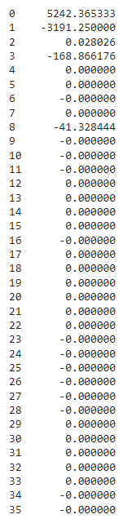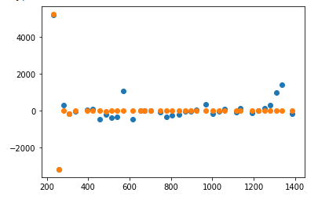

**7**

**OUTLIERS REMOVED**

est_gp = SymbolicRegressor(population_size=1000,

generations=2000, stopping_criteria=110,

p_crossover=0.8, p_subtree_mutation=0.05, function_set=function_set,

p_hoist_mutation=0.01,

p_point_mutation=0.1,

max_samples=0.90, verbose=1,

parsimony_coefficient=.5, random_state=0)

Length: 52

Fitness: 118.67

R2: 0.7586653976092999

sub(div(inv(add(inv(mul(-0.863, X7)), div(X5, X3))), mul(-0.863, -0.863)), sub(X4, sub(div(X5, X3), inv(div(mul(mul(-0.863, -0.863), mul(-0.863, X3)), div(add(div(inv(add(mul(-0.863, -0.863), mul(X5, add(inv(mul(-0.863, X7)), -0.863)))), mul(-0.863, X7)), X1), div(X8, X4)))))))

-X4 - 1.34269820575239/(1.15874855156431/X7 - X5/X3) + 1.55584960110358*X4*(X1 + 1.15874855156431/(X7*(X5*(0.863 + 1.15874855156431/X7) - 0.744769)))/(X3*X8) + X5/X3

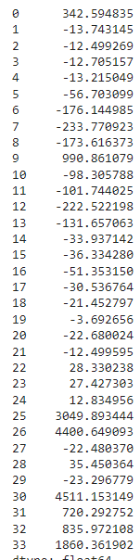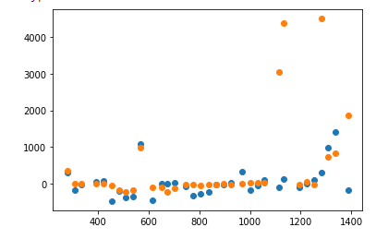

**8**

Lower stopping_criteria, higher generations

est_gp = SymbolicRegressor(population_size=1000,

generations=3000, stopping_criteria=100,

p_crossover=0.8, p_subtree_mutation=0.05, function_set=function_set,

p_hoist_mutation=0.01,

p_point_mutation=0.1,

max_samples=0.90, verbose=1,

parsimony_coefficient=.5, random_state=0)

Length: 51

Fitness: 98.8854

R2: 0.8528424388782602

sub(div(inv(add(inv(mul(-0.863, X7)), div(X5, X3))), mul(-0.863, -0.863)), sub(X4, sub(sub(add(inv(mul(-0.863, sub(div(X5, X3), inv(X5)))), div(X5, X3)), inv(div(mul(-0.863, X3), div(X1, div(X8, X4))))), inv(div(mul(-0.863, X3), div(X1, div(X8, X4)))))))

2.31749710312862*X1*X4/(X3*X8) - X4 - 1.34269820575239/(1.15874855156431/X7 - X5/X3) + 1/(0.863/X5 - 0.863*X5/X3) + X5/X3

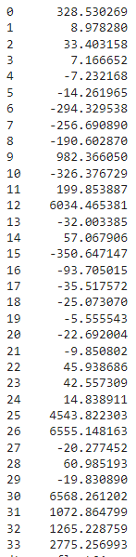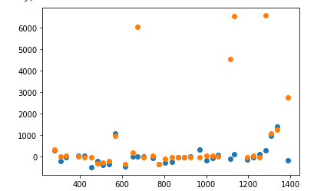

**9**

Slightly higher parsimony, lower stopping criteria

est_gp = SymbolicRegressor(population_size=1000,

generations=10000, stopping_criteria=75,

p_crossover=0.8, p_subtree_mutation=0.05, function_set=function_set,

p_hoist_mutation=0.01,

p_point_mutation=0.1,

max_samples=0.90, verbose=1,

parsimony_coefficient=.55, random_state=0)

Length: 86

Fitness: 73.987

R2: 0.8900167148177383

add(add(add(add(add(div(X5, X3), inv(sub(inv(mul(-0.863, X7)), inv(div(X4, neg(div(div(X5, X3), 0.656))))))), inv(sub(inv(mul(-0.863, X7)), inv(div(X4, inv(mul(-0.863, X7))))))), inv(mul(-0.863, add(div(X5, X3), inv(sub(sub(inv(div(inv(mul(-0.863, X7)), X4)), mul(-0.863, X7)), X6)))))), inv(mul(-0.863, div(div(X3, X4), inv(div(div(X3, X4), neg(add(X6, X6)))))))), div(sub(inv(add(div(X5, X3), inv(mul(-0.863, X7)))), X4), 0.656))

-1.52439024390244*X4 + 1/(0.863/(0.863*X4*X7 + X6 - 0.863*X7) - 0.863*X5/X3) - 1/(1.15874855156431/X7 - 1.52439024390244*X5/(X3*X4)) - 1/(1.15874855156431/X7 - 1.15874855156431/(X4*X7)) - 1.52439024390244/(1.15874855156431/X7 - X5/X3) + X5/X3 + 2.31749710312862*X4**2*X6/X3**2

**10**

est_gp = SymbolicRegressor(population_size=1000,

generations=10000, stopping_criteria=75,

p_crossover=0.8, p_subtree_mutation=0.05, function_set=function_set,

p_hoist_mutation=0.01,

p_point_mutation=0.1,

max_samples=0.90, verbose=1,

parsimony_coefficient=.5, random_state=0)

sub(div(inv(add(inv(mul(-0.863, X7)), div(X5, X3))), mul(-0.863, -0.869)), sub(X4, sub(sub(add(inv(mul(-0.869, sub(div(X5, div(X1, div(X8, X4))), inv(X5)))), add(inv(inv(mul(-0.863, X7))), add(inv(mul(-0.863, sub(div(X5, div(X1, X8)), inv(X5)))), div(X5, X3)))), inv(div(mul(-0.863, X3), div(X1, div(X8, X4))))), inv(div(mul(-0.863, X3), div(X1, div(X8, X4)))))))

Length: 73

Fitness: 72.1373

R2: 0.8722056052937441

2.31749710312862*X1*X4/(X3*X8) - X4 - 0.863*X7 - 1.3334275622144/(1.15874855156431/X7 - X5/X3) + 1/(0.869/X5 - 0.869*X5*X8/(X1*X4)) + 1/(0.863/X5 - 0.863*X5*X8/X1) + X5/X3

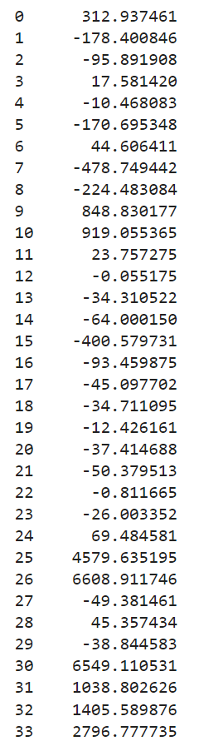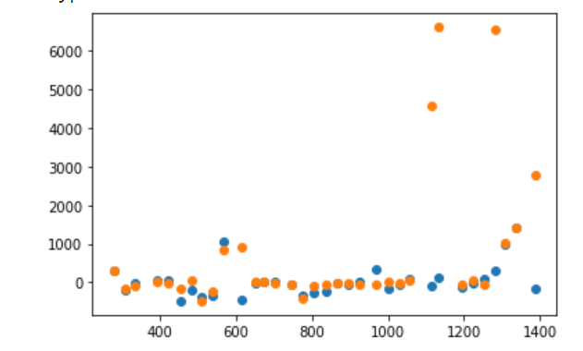

**11 - LOGS**

Log function applied: ln(count(t+1)/count(t)) / (t+1 - t)

Note: Symbolic regression does not work well with small values and high parsimony. Fitness is too small so it just begins to use 1 variable

#Symbolic Regression Parameters - LOWER PARSIMONY

est_gp = SymbolicRegressor(population_size=1000,

generations=10000, stopping_criteria=.0001,

metric='mean absolute error',

p_crossover=0.8, p_subtree_mutation=0.05, function_set=function_set,

p_hoist_mutation=0.01,

p_point_mutation=0.1,

max_samples=0.90, verbose=1,

parsimony_coefficient=.001, random_state=0)

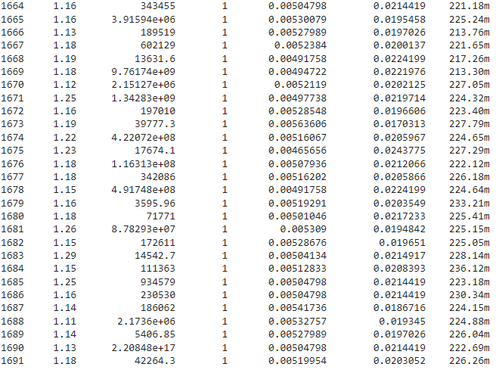

SUPER LOW Parsimony, reasonable stopping criteria

est_gp = SymbolicRegressor(population_size=1000,

generations=10000, stopping_criteria=.0030,

metric='mean absolute error',

p_crossover=0.8, p_subtree_mutation=0.05, function_set=function_set,

p_hoist_mutation=0.01,

p_point_mutation=0.1,

max_samples=0.90, verbose=1,

parsimony_coefficient=.000013, random_state=0)

div(X4, add(add(X2, div(add(add(-0.200, X3), X3), sub(neg(inv(div(X5, -0.283))), X0))), add(div(add(mul(-0.200, X3), X3), add(inv(inv(div(X5, -0.283))), sub(X3, X1))), add(inv(inv(div(X5, -0.283))), sub(X3, X1)))))

Length: 43

Fitness: 0.00298745

R2: 0.3625942367341368

-X4/(X1 - X2 - X3 + 0.8*X3/(X1 - X3 + 3.53356890459364*X5) + 3.53356890459364*X5 + (2*X3 - 0.2)/(X0 - 0.283/X5))

#Symbolic Regression Parameters

est_gp = SymbolicRegressor(population_size=1000,

generations=10000, stopping_criteria=.0025,

metric='mean absolute error',

p_crossover=0.8, p_subtree_mutation=0.05, function_set=function_set,

p_hoist_mutation=0.01,

p_point_mutation=0.1,

max_samples=0.90, verbose=1,

parsimony_coefficient=.000008, random_state=0)

R2: 0.19680863916543745

Length: 52

Fitness: 0.00249542

div(neg(X4), neg(add(add(add(X2, sub(X3, X1)), div(X3, div(div(sub(X2, div(div(X3, X3), div(neg(mul(X5, X5)), neg(X3)))), X3), neg(sub(X3, div(X3, div(neg(mul(X5, X5)), neg(sub(X3, X8))))))))), div(X3, div(neg(mul(X5, X5)), neg(X3))))))

X4*X5**2*(X2*X5**2 - X3)/(-X3**3*X5**2*(-X3 + X5**2 + X8) + X3**2*(X2*X5**2 - X3) + X5**2*(X2*X5**2 - X3)*(-X1 + X2 + X3))

No coefficients - lowest parsimony?